OCTOBER 2026 APARTMENT LISTING
ALL APARTMENTS ARE UNFURNISHED
SECTION 8 WILL PAY A MAXIMUM HCV FAIR MARKET VALUE RENTAL AMOUNT
OF BETWEEN $1,000 AND $1,700 PER MONTH FOR UNITS IN THIS COMMUNITY RESOURCE LISTING AREA
PLEASE NOTE: CALL OR CONTACT EACH LISTING TO VERIFY AVAILABILITY, FEES, AND VOUCHER ACCEPTANCE BEFORE APPLYING.
ADDRESS | AMOUNT | AVAILABILITY | VIEW / PHOTO LINK | CONTACT INFORMATION | HOUSING VOUCHERS /  SECTION 8 | DESCRIPTION
PASSAIC COUNTY
377 Madison St Unit 10  Passaic, NJ 07055 | $1,545/mo  1 bd, 1 ba  700 sq ft | NOW | 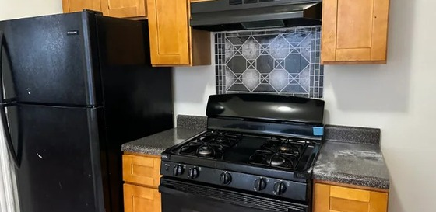 | John Stevenson  eRealty Advisors, Inc.  862-304-5255 | Not stated - verify before applying | Remodeled one-bedroom with eat-in kitchen, fresh paint, heat/hot water included, near Christopher Columbus Park and downtown Passaic. Confirm fees and vouchers.
551 Summer St Unit 2R  Paterson, NJ 07501 | $1,475/mo  2 bd, 1 ba | NOW | 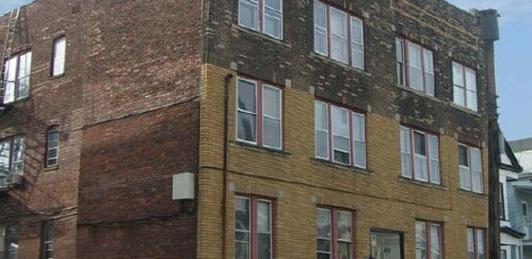 | 551 Summer St Leasing  862-310-6309 | Not stated - verify before applying | Two-bedroom Paterson apartment with hardwood floors, included water/trash/sewer and strong commuter access to trains, buses and major highways. Confirm deposit.  PET POLICY: Pets allowed; cats and dogs allowed.
148 Clinton St Unit 2  Paterson, NJ 07522 | $1,475/mo  1 bd, 1 ba | NOW | 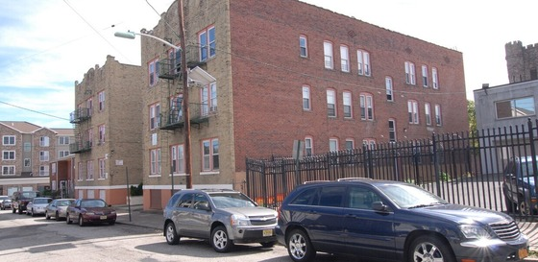 | 148 Clinton St Leasing  862-319-3466 | Not stated - verify before applying | One-bedroom Paterson apartment within range. Confirm floor level, appliances, utilities, parking, move-in costs, application requirements and voucher policy.
154 Hamilton Ave Unit 202  Paterson, NJ 07501 | $1,450/mo  Studio, 1 ba | NOW | 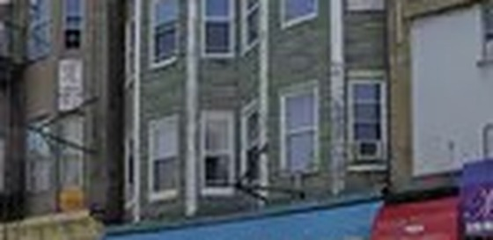 | 154 Hamilton Ave Leasing  862-319-8366 | Not stated - verify before applying | Studio Paterson apartment with stainless appliances, hardwood-style flooring, central air, secure entry and security monitoring. Confirm fees, deposit and parking.  PET POLICY: Pets allowed; pet-friendly community.
100 Rosa Parks Blvd Unit B1B  Paterson, NJ 07501 | $1,500/mo  1 bd, 1 ba | NOW | 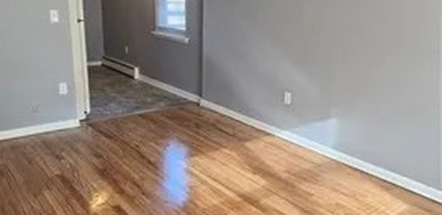 | 100 Rosa Parks Blvd Leasing  201-467-9294 | Not stated - verify before applying | One-bedroom Paterson apartment listed at $1,500. Confirm move-in readiness, building rules, utilities, parking, lease terms and voucher policy.
54 Center St  Clifton, NJ 07011 | $1,300/mo  1 bd, 1 ba | NOW | 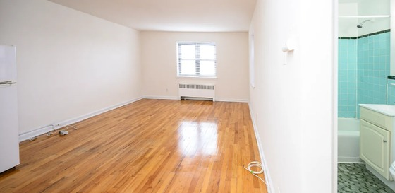 | 54 Center St Leasing  973-686-1500 | Not stated - verify before applying | One-bedroom Clifton apartment within range. Confirm unit layout, appliances, utilities, parking, laundry access, fees, deposit and voucher policy.
ADDRESS | AMOUNT | AVAILABILITY | VIEW / PHOTO LINK | CONTACT INFORMATION | HOUSING VOUCHERS /  SECTION 8 | DESCRIPTION
ESSEX COUNTY
61 S Munn Ave Unit 104  East Orange, NJ 07018 | $1,395/mo  Studio, 1 ba | NOW | 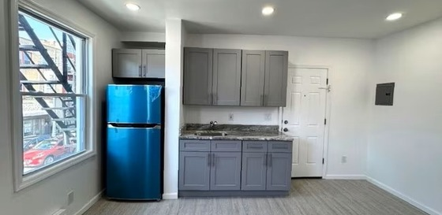 | 61 S Munn Ave Leasing  862-418-1136 | Not stated - verify before applying | Studio East Orange apartment with hardwood floors, security features and access to shopping, services and transportation. Confirm fees, utilities and voucher policy.  PET POLICY: Pets allowed.
18 Summit St  East Orange, NJ 07017 | $1,200/mo  1 bd, 1 ba | NOW | 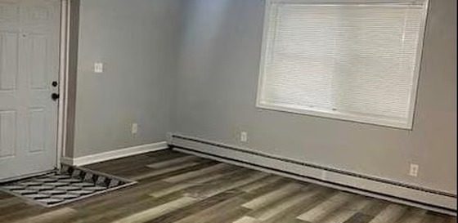 | 18 Summit St Leasing  862-322-6741 | Not stated - verify before applying | Renovated East Orange apartment within range. Confirm unit number, utilities, laundry access, parking, deposit, lease terms and voucher policy.
273 S Orange Ave Unit 273D  Newark, NJ 07103 | $1,225/mo  Studio, 1 ba | NOW | 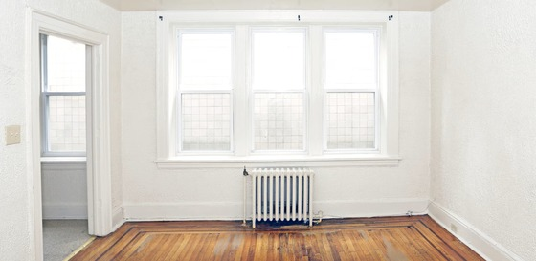 | 273 S Orange Ave Leasing  973-318-3497 | Not stated - verify before applying | Studio Newark apartment near transportation and neighborhood stores, with parking noted. Confirm appliances, fees, utilities, deposit and voucher policy.
94 Fairmount Terrace Unit 412  East Orange, NJ 07018 | $1,500/mo  1 bd, 1 ba | NOW | 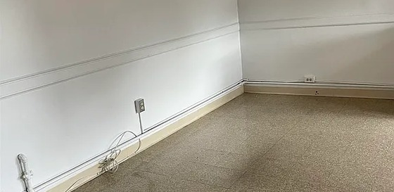 | 94 Fairmount Terrace Leasing  862-386-2983 | Not stated - verify before applying | One-bedroom East Orange apartment within range. Confirm building access, floor level, utilities, laundry, parking, application requirements and voucher policy.
125 Osborne Terrace Unit 14  Newark, NJ 07108 | $1,500/mo  1 bd, 1 ba | NOW | 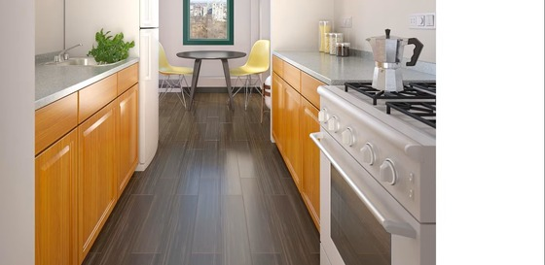 | 125 Osborne Terrace Leasing  732-795-5397 | Not stated - verify before applying | One-bedroom Newark apartment listed at $1,500. Confirm unit condition, appliances, utilities, parking, application requirements, deposit and move-in costs.
12 Elmwood Ave Unit BL 1  Bloomfield, NJ 07003 | $1,300/mo  1 bd, 1 ba | NOW | 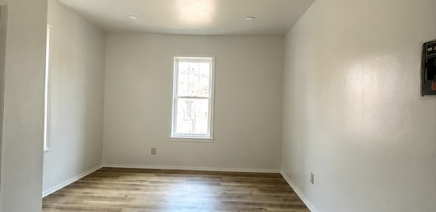 | 12 Elmwood Ave Leasing  848-800-2391 | Not stated - verify before applying | Bloomfield apartment with eat-in kitchen, stove, refrigerator, heat/hot water, hardwood floors, coin laundry and parking option. Confirm fees and vouchers.

ADDRESS | AMOUNT | AVAILABILITY | VIEW / PHOTO LINK | CONTACT INFORMATION | HOUSING VOUCHERS /  SECTION 8 | DESCRIPTION
UNION COUNTY
231 Ripley Pl Unit 4  Elizabeth, NJ 07206 | $1,400/mo  1 bd, 1 ba | NOW | 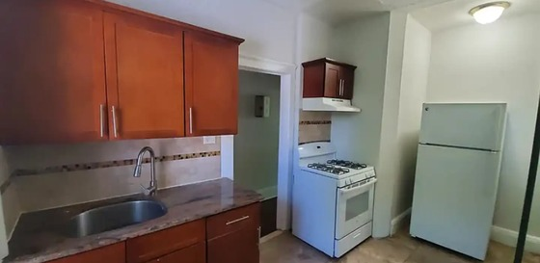 | Chad H  908-266-6581 | Not stated - verify before applying | One-bedroom Elizabeth apartment with oven, refrigerator, tile floors and utilities noted as included. Confirm move-in date, deposit and voucher policy.
Sheridan Gardens  1093 Sheridan Ave, Elizabeth, NJ 07208 | $1,400/mo  Studio, 1 ba | NOW | 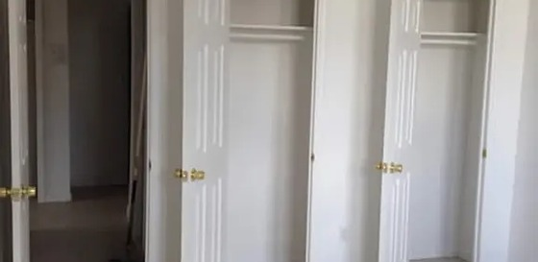 | Sheridan Gardens Leasing  908-739-6919 | Not stated - verify before applying | Studio apartment option in Elizabeth within range. Confirm exact unit, included services, parking, laundry, deposits, fees and voucher policy.
516 E Jersey St Unit 3  Elizabeth, NJ 07206 | $1,500/mo  2 bd, 1 ba  750 sq ft | NOW | 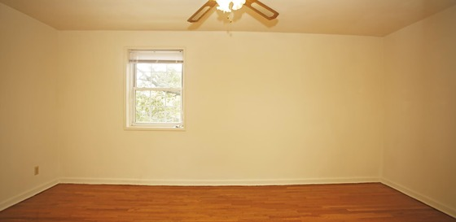 | 516 E Jersey St Leasing  908-965-8340 | Not stated - verify before applying | Two-bedroom Elizabeth apartment with modern flooring, natural light and updated bathroom. Confirm utilities, fees, deposit, lease terms and voucher policy.
Westminster Towers Apartments  801 N Broad St, Elizabeth, NJ 07208 | $1,400/mo  Studio | NOW | 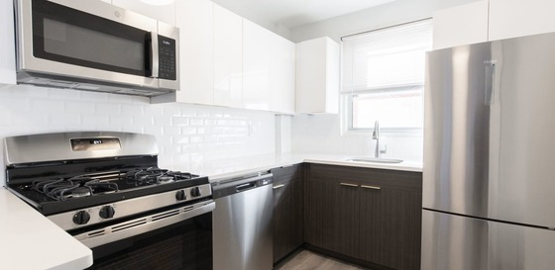 | Westminster Towers Apartments Leasing  908-738-9911 | Not stated - verify before applying | Studio apartment option at Elizabeth community with management support and emergency maintenance noted. Confirm availability, utilities, parking, fees and vouchers.
Wood Arms Apartments  30 E Elm St, Linden, NJ 07036 | $1,450+/mo  Studio | NOW | 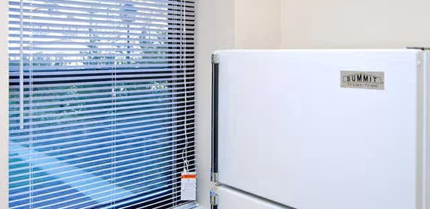 | Wood Arms Apartments Leasing  908-663-1872 | Not stated - verify before applying | Studio Linden apartment near shopping, transportation and neighborhood services. Confirm available unit, utilities, laundry, parking, fees and voucher policy.
Portside II  136 Pine St, Elizabeth, NJ 07206 | $1,017/mo 1 bd  $1,209+/mo 2 bd  $1,397+/mo 3 bd | NOW | 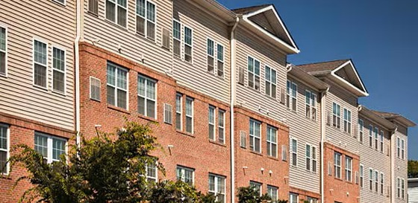 | Portside II Leasing  201-423-6440 | YES - income-restricted community; verify voucher eligibility | Income-restricted Elizabeth community with one-, two- and three-bedroom options. Confirm availability, household rules, income qualifications and voucher eligibility.
Important: Availability, rent, fees, pet rules, voucher policies and income limits can change. Confirm all terms directly with the named property contact before applying or paying a fee.

